Dashboard Design
Date | 12 August 2026
Team ID
Project Name | India’s Agricultural Crop Production Analysis
Maximum Marks | 5 Marks

Creating an effective dashboards involves thoughtful design to ensure that the presented information is clear, relevant and easily understandable for the intended audience . Here are some key principles and best practices for dashboard design.
Activity 1: Interactive and visually appealing dashboards
Creating interactive and visually appealing dashboards involves a combination of thoughtful design, effective use of visual elements and the incorporation of interactive features. Here are some tips to help you design dashboards that are both visually appealing and engaging for users so take care of below points
- Clear and Intuitive Layout
- Use Appropriate Visualization
- Colour and Theming
- Interactive Filters and Slicers
- Drill-Down Capabilities
- Responsive Design
- Custom Visuals and Icons
- Use of Infographics
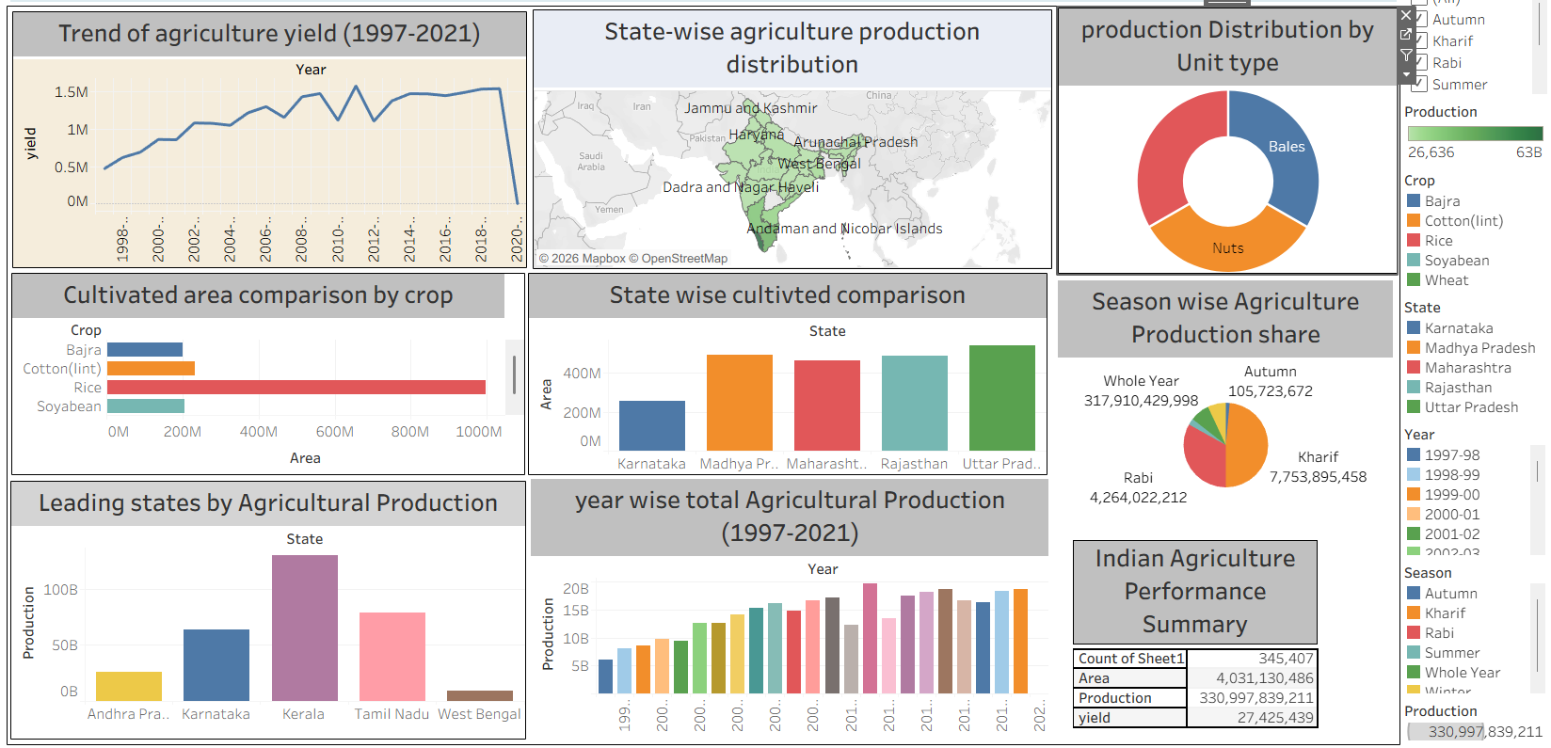

Major Outcomes from India Agriculture dashboards
- Yield Trend Analysis (1997-2021): The dashboard shows a steady increase in agriculture yield from 1997(0.5M) to 2012 (1.5M peak), with fluctuations after 2012 and a sharp decline in 2020, indicating impact of climate or pandemic on yield.
- Highest Cultivated Crop: Rice has the highest cultivated area covering more than 1000M hectares, followed by Soyabeen and Bajra. This shows Rice is the most dominant crop in terms of area coverage in India.
- State-wise Production Leadership: Kerala is the leading state by agricultural production, followed by Karnataka and Tamil Nadu. In terms of cultivated area Madhya Pradesh and Uttar Pradesh have the highest cultivated area, highlighting central India’s dominance.
- Season-wise Production Share: Whole year season contributes the maximum Production share with 317.9B, followed by Kharif with7.75B and Rabi with 4.26B. This shows year round crops have major contribution compared to seasonal crops.
- Year-wise Production Growth: Total agricultural production shows a consistent growth trend from 1999 to 2019, with peak production in the years 2015-2019, indicating improvement in farming techniques area expansion.
- Overall Performance Summary: As per Indian Agriculture Performance Summary, total production is 330,997.84Mwith total area of 4031.13M and total yield of 27.43M, covering all major states and seasons.

Activity 2: Publish Dashboards on Tableau Public and Paste the Dashboards Public link
https://public.tableau.com/views/IndianAgriculturalData_17880613420090/Dashboard1?:language=en-US&publish=yes&:sid=&:redirect=auth&:display_count=n&:origin=viz_share_link

